



BUDGETBASICS
Personal Finance & Budgeting Platform (SPA)

SUBMITTED BY: “SYNTAX TERMINATORS”

Student ID | Member Name | Project Role & Responsibilities
Student1734315 | MOHAMMAD UMER | Team Lead / Frontend Developer
Student1734141 | UMAR . | UI/UX Designer & Information Architect
Student1731375 | MUHAMMAD SAADI | Logic Developer / Calculator Engine Specialist
Student1734145 | GHULAM HUSSAIN | QA, Testing & Technical Documentation Specialist

1. Executive Summary & Problem Definition

1.1 Project Overview
- Project Title: BudgetBasics - Personal Finance & Budgeting Platform
- Domain: EdTech / Personal Finance Management
- Category: Web Innovation Unleashed | Theme: NextGen Budget Bee
- Architecture: Single Page Application (SPA) with responsive HTML5, CSS3, JavaScript, and Bootstrap
- Document Version: 3.0

1.2 Problem Statement & Proposed Solution
Managing personal finances is a crucial life skill, yet many students struggle to track allowances, scholarships, or internship earnings. Small daily expenses reduce funds needed for essential requirements and savings. BudgetBasics addresses this challenge through an intuitive, student-friendly Single Page Application (SPA) that delivers interactive guides, visual infographics, 50-30-20 budget calculators, goal planning tools, and an AI Q&A chatbot assistant without requiring complex backend database management.

1.3 Proposed Solution
BudgetBasics is a responsive, student-focused Single Page Application that combines educational budgeting content with practical client-side tools. The platform provides budgeting basics, a Needs vs Wants classifier, a 50-30-20 calculator, savings-goal planning, an expense planner, money-mistake guidance, infographic learning resources, searchable tips, a rule-based AI-style chatbot, and validated feedback/contact forms. Its content is supplied through pre-defined JSON datasets, while calculations and temporary expense-planner interactions run in the browser without a backend database.

2. System Architecture & Visual Technical Diagrams

2.1 Complete Information Architecture & Sitemap Diagram
The sitemap structure below defines the visual navigation hierarchy and component flow of the Single Page Application:
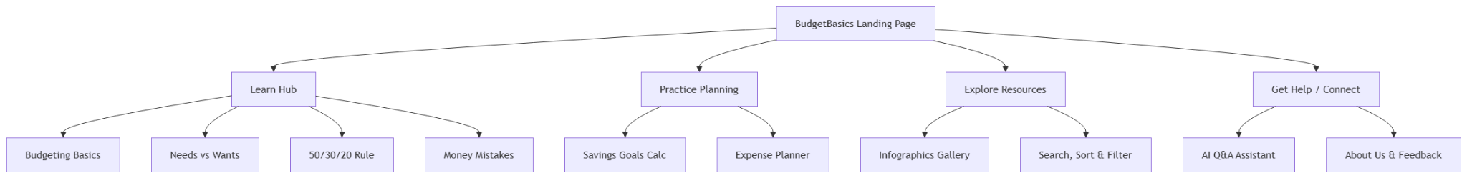

2.2 Data Flow Diagram (DFD Level 1)
The DFD illustrates client-side data interaction between the student user, execution logic, pre-populated static datasets, and UI views:

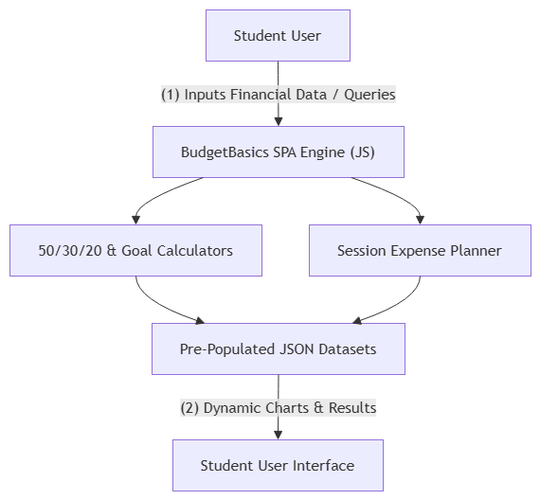

2.3 Logic & Activity Flowchart
The activity flowchart highlights input validation and calculation workflows:

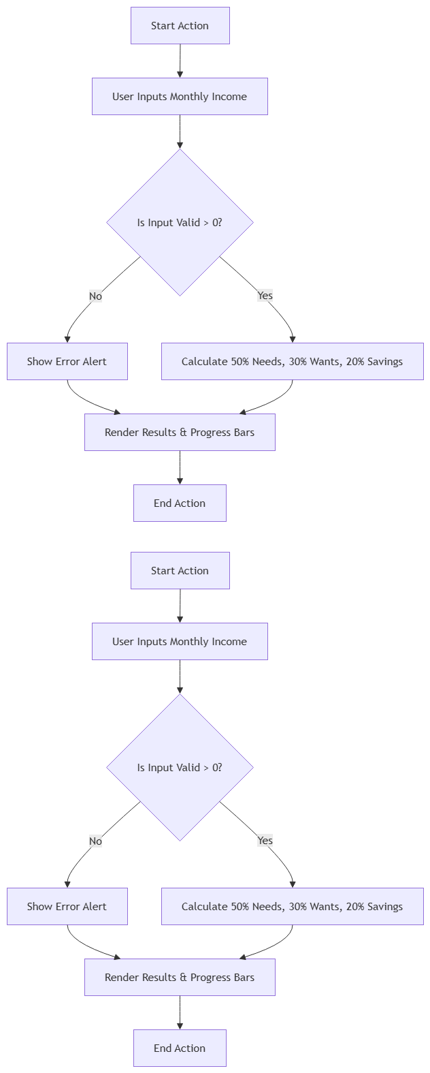

3. Functional Requirements Specifications

Module ID | Module Name | Functional Description | Implementation Tech
FR-01 | Landing & Navigation | Global responsive navbar with active states, dark mode toggle, smooth scrolling, visitor counter, and real-time clock. | HTML5, CSS3, JavaScript DOM manipulation
FR-02 | Budgeting Basics & Needs vs Wants | Educational cards explaining fixed vs. variable income, and interactive Needs vs. Wants classifier. | Dynamic JS card rendering
FR-03 | 50-30-20 Budget Calculator | Accepts income input, calculates 50% needs, 30% wants, and 20% savings with progress visualizers. | JavaScript math logic & Bootstrap progress bars
FR-04 | Savings Goals Calculator | Calculates target savings, monthly contributions, remaining amount, and projected completion timeline. | Form validation & arithmetic calculations
FR-05 | Expense Planner Demonstration | Allows users to add, edit, calculate total, and remove sample expense items in a temporary session table. | In-memory JavaScript arrays & DOM tables
FR-06 | Money Mistakes Module | Accordion-based cards highlighting common pitfalls like impulse buying, unused subscriptions, and late fees. | Bootstrap Accordions / Interactive cards
FR-07 | Infographics & Learning Gallery | Visual infographics gallery showcasing financial workflows with topic filtering. | CSS Grid & filter JS scripts
FR-08 | AI Chatbot Assistant | Rule-based Q&A chatbot answering financial queries using pre-defined JSON datasets. | Regex keyword matching & JSON fetch
FR-09 | Search, Sort, and Filter | Keyword search bar filtering learning tips, calculators, and infographics instantly. | Client-side array filtering
FR-10 | About Us & Validated Feedback | Creator profile information and client-side validated contact/feedback forms with modal popups. | Regex form validation & Bootstrap modals
FR-11 | Additional UX Features | Animated cards, tips ticker, back-to-top control, keyboard accessibility, and Lighthouse score optimization. | CSS3 animations & ARIA attributes
FR-12 | JSON | Stores and organizes website content and data in a structured format for easy access and management.
  JSON is used for data storage, while JavaScript reads and displays the data dynamically on the website.

4. System Specifications & Non-Functional Quality Attributes

4.1 Hardware & Software Specifications
- Processor: Dual-Core Intel Core i5/i7 or AMD Ryzen equivalent (2.0 GHz+)
- System Memory: 8 GB RAM or higher
- IDE / Development Tools: Visual Studio Code
- Frontend Stack: HTML5, CSS3, JavaScript (ES6+), Bootstrap Framework
- Data Handling: Static JSON datasets & Browser Local Storage
Display Output: Color display supporting desktop, tablet, and mobile responsive layouts.
Storage Space: Minimum 500 MB free disk space recommended for the project files, development tools, and browser cache.
Development IDE: Visual Studio Code.
Design Tools: Figma AI was used for layout/design ideation; the final UI was manually integrated and verified.
Development Assistance: ChatGPT and Gemini were used as supporting productivity aids for CSS optimization, debugging assistance, and JSON dataset formatting.

4.2 Non-Functional Quality Matrix
Quality Attribute | Specification & Standard
Accessibility | Fully keyboard navigable, WCAG compliant with clear contrast, aria-labels, and alt text.
Compatibility | Cross-browser tested on Chrome, Firefox, Edge, and Safari across desktop, tablet, and mobile views.
Performance | Lightweight assets, zero backend overhead, sub-second execution, optimized Lighthouse score.
Privacy & Reliability | Zero server-side transmission or unauthorized tracking; strict input validation and boundary checks.

4.3 Data Resources & Project Assumptions
The submission ZIP contains 20 JSON resources covering navigation, site content, budgeting, savings, needs-vs-wants, expense planning, chatbot content, infographics, feedback/contact data, search data, quizzes, UI settings, and related static content. The project uses no backend database or user-account system; calculator results are generated client-side, and expense-planner entries are temporary session data.

5. Non-Functional Quality Attributes
The project emphasizes responsive behavior, keyboard accessibility, readable content, lightweight client-side execution, cross-browser compatibility, and privacy-oriented client-side processing. These qualities are implemented through responsive CSS, ARIA/focus support, optimized assets, and avoidance of server-side transmission.

6. Implementation & Installation Setup

6.1 Installation Steps (Mandatory Run Guide)
- Extract the project ZIP archive to your local directory.
- Ensure standard directory structure (`index.html`, `CSS/`, `JS/`, `data/`, `ReadMe.doc`).
- Open folder in Visual Studio Code and launch via Live Server (`http://127.0.0.1:5500`).

7.1 Sample Test Data Configurations
Test ID | Scenario | Inputs | Expected Output | Status
TC-01 | 50-30-20 Split Calculation | Income = $50,000 | Needs=$25,000, Wants=$15,000, Savings=$10,000 | PASSED
TC-02 | Savings Target Estimator | Goal=$10,000, Saved=$2,000, Monthly=$1,000 | Remaining=$8,000 | Estimated Time = 8 Months | PASSED
TC-03 | Form Validation Check | Submit empty contact form | Prevents submission, displays field highlight alerts | PASSED

8.1 AI Usage Statement & Declaration
AI tools (ChatGPT, Gemini, Figma AI) were used strictly as supporting productivity aids for layout ideas, CSS optimization, and JSON dataset formatting. All final core logic, system architecture, component integration, and document preparation were manually designed, implemented, and verified by team SYNTAX TERMINATORS.

9. Deliverables Verification Checklist
☑ Complete Project Source Code ZIP Archive — Present (data.zip).
☑ Formal Documentation Project Report — Present (this document).
☑ Technical ReadMe File — The supplied ZIP contains readme-data. Json with deployment and project assumptions; no separate ReadMe.doc file was found in the supplied archive.
☑ Video Demonstration Recording (.mp4) — Not present in the supplied ZIP archive; verify separately before submission.
☑ Test Datasets & Static Configuration Files — Present; JSON datasets are included in the data/ directory.

Test Scenario A: Core Input Validation & Calculation
Test Input Values: Income = $50,000 for the 50-30-20 calculator.
Expected Calculation Result: Needs = $25,000; Wants = $15,000; Savings = $10,000.
Actual Output: Passed; the existing verification table records TC-01 as PASSED.

Test Scenario B: Dynamic Data Filtering Engine
Search Term: Example terms include “budget”, “saving”, “needs”, or “impulse”, matching the supplied search-data. Json keyword dataset.
Expected Filtered Results: Relevant budgeting resources are matched and the displayed results are updated through client-side filtering.
Actual Result: The project includes search-data. Json and client-side array filtering as documented in the functional requirements.

AI Usage Scope
UI/UX & Asset Generation: Figma AI was used for layout/design ideas. Code & Logic Structuring: ChatGPT and Gemini were used for supporting debugging, CSS optimization, and JSON dataset formatting. Final code execution, integration, architecture, and verification remained the responsibility of SYNTAX TERMINATORS.

